JENKINS OVERVIEW

Maven cơ bản: is a [build automation](https://en.wikipedia.org/wiki/Build_automation) tool used primarily for [Java](https://en.wikipedia.org/wiki/Java_(programming_language)) projects

* how software is built
* its dependencies

compiling and packaging

Maven

Default

Clean

Site

removing temporary files

source files, compiled classes, previous JAR files …

generating documentation

**Three standard lifecycles

* Clean
* Pre – clean.
* Clean
* Post- clean
* Default (or build)
* Validate 🡪 Check, the Project is correct and all information is available.
* Compile 🡪 Compile the source code.
* Test 🡪 Run test against the compile source code.
* Package 🡪 Packs the compile code.
* Install 🡪 Install result in local.
* Deploy 🡪 Copies the final package to the remote repository 🡪 sharing with other developers and projects.
* Site
* Pre – site
* Site
* Post – site
* Site – deploy

Maven

Clean

Execute

Compile

Test

Maven Pom [Project Object Model](https://en.wikipedia.org/wiki/Project_Object_Model)

* Là một file xml
* Chứa thông tin về dự án và chi tiết các cấu hình dùng để xây dựng dự án
* Một vài cấu hình đặc trưng của POM:
* Project dependencies
* Plugins
* Goals
* Build profiles
* Project version
* Developers
* Mailing list
* Build project with Maven
* Package = jar 🡪 In pom.xml: <packaging>jar</packaging>
* Package = war 🡪 In pom.xml: <packaging>war</packaging>
* Create project

mvn archetype:generate -DgroupId=com.mycompany.app -DartifactId=my-app -DarchetypeArtifactId=maven-archetype-quickstart -DinteractiveMode=false

* Build project: mvn package
* Test: java -cp target/my-app-1.0-SNAPSHOT.jar com.mycompany.app.App
* Generating the Site: mvn site
* Clean project, copy dependencies and package:

mvn clean dependency:copy-dependencies package

**Manage Jenkins:**

**Config System:** Configure global settings and paths

* + - Home directory
    - Environment Variables
    - Jenkins URL
    - Jenkins Location
    - Number of Executors:
* the total concurrent job executions
* should be set to equal the number of CPU that you have for optimal performance.
* make change in the master (Jenkins Host) only
* any slave machine, you need to manually change

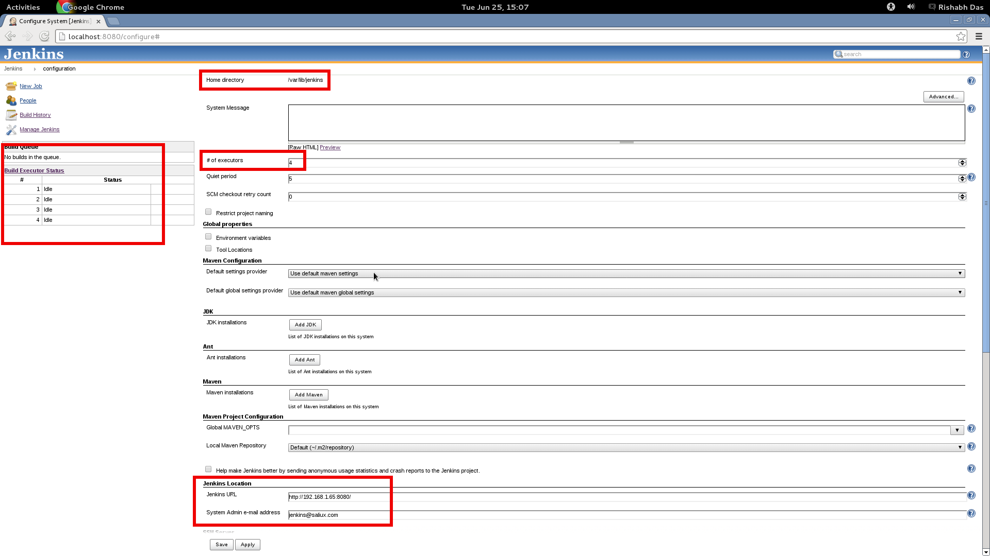

**Managing Global Security :**

* + - * + configuration options for enabling, editing, or disabling various security features.
        + safely support 🡪 security and threat profiles
      * From the ‘Manage Jenkins’ page, click on Configure Global Security.
      * Check ‘Enable Security’
      * In the Access Control section, there are many options available for configuration.
      * Click on ‘Jenkins own user database’ and un-check ‘Allow users to Sign-Up’.
      * Select Matrix Based Security
      * Add existing users to the user matrix and grant/revoke permissions as required.
      * Click save.

## Managing Tools : Built-in tool providers

### Ant

#### Ant build step

### Git

### JDK

### Maven

**Managing Users :**

1. From the Manage Jenkins page, select Manage Users.
2. Click on ‘Create User’ link in the left side.
3. You will be presented with a Sign Up form.
4. Create user by filling in the requested information.

# Managing Nodes:

# Script Console :

# [Jenkins CLI](https://jenkins.io/doc/book/managing/cli):

# command line interface that allows users and administrators to access Jenkins from a script or shell environment

# [Managing Plugins](https://jenkins.io/doc/book/managing/plugins):

# managing plugins

On Jenkins dashboard, Click on New Item

Enter the Item name, choose type project -> OK

Location of files which need to be built ( enter URL Git)

At Build, click on Add build step → Execute Windows batch command

Once saved, click on the Build Now option

**Create Jobs**

Details of the job

.

In command, enter command 🡪 click Apply -> Save Button

Click on the Console Output link to see the details of the build

Style:

* Freestyle project:
* Central feature.
* Combine any SCM
* Maven project
* POM files advantage.
* Reduces the config.
* Pipeline
* Multiple build slaves.
* Complex activities.
* External jobs
* Record the execution of the process run outside Jenkins
* Multi – configuration project
* A large number of different config
* Folder
* Container store nested items in it.
* Github Organization
* Scan github matching some define
* Multibranch Pipeline
* Create a set pipeline

|  |  |  |  |  |  |  |  |  |
| --- | --- | --- | --- | --- | --- | --- | --- | --- |
| Style | FreeStyle | Maven | Pipeline | External | Multi-Cog Project | Folder | Github | Multibranch |
| Source Code Management | X | X |  |  | X |  |  |  |
| Build Trigger | X | X | X |  | X |  |  |  |
| Build Enviroment | X | X |  |  | X |  |  |  |
| Build | X | X |  |  | X |  |  |  |
| Post-build Actions | X | X |  |  | X |  |  |  |
| Maven config |  | X |  |  |  |  |  |  |
| Pre Step |  | X |  |  |  |  |  |  |
| Post Step |  | X |  |  |  |  |  |  |
| Advanced Project Option |  |  | X |  | X |  |  |  |
| Pipeline |  |  | X |  |  |  |  |  |
| Config Matrix |  |  |  |  | X |  |  |  |
| General | X | X | X | X | X | X | X | X |

Manage Jenkins > Manage Nodes

New Node --> Enter Node Name.

Fill information

Connect slave machine to master

Service to run on start-up

**Create Slave**

Select Permanent Agent --> Press OK.

**Build project in Slave**

On dashboard, Click on Project

Click “Config”

Click “Restrict where this project can be run”

Apply ->Save

Build and check result

Fill label Expression 🡪” **slave label**” not Slave Name

Plugin

Phần mở rộng trong Jenkins

Có thể thay đổi giao diện hoặc thêm chức năng mới cho Jenkins

Hỗ trợ các dự án không dùng ngôn ngữ java

tích hợp hầu hết các hệ thống quản lý mã nguồn và cơ sở dữ liệu

* Connect from Master to Slave is TCP/IP

<https://www.quora.com/What-is-the-use-of-master-and-slave-in-Jenkins>

Jenkin Master:

* Scheduing build jobs.
* Dispatching( Phân phát) the Slaves for execute.
* Build the slaves.
* Monitor (giám sát) the slaves.
* Execute(Điều hành) build result.
* Record and present the built result.

Jenkins Slave:

* Hears request from master
* Can run on a variety of operating system.
* Execute jobs
* Config slave machine, type of Slave
* Jenkins can pick available slave.